**FATIMA JINNAH WOMEN UNIVERSITY**



**E-Hospital Management System**

**(Report)**

**Submitted to:** Sir Adeel **Submitted by:**

Romaisa (2023-BCS-073)

Javeria Rahim (2023-BCS-046)

Sameen Noor (2023-BCS-077)

Malaika (2023-BCS-056)

**Course:** Database System

**Section:** BCS-IIB

**Department of Computer Science.**

# FATIMA JINNAH WOMEN UNIVERSITY

**RAWALPINDI**

**www.fjwu.edu.pk**

**Background:**

In the healthcare sector, the shift towards digital solutions is driven by the need for efficiency, accuracy, and improved patient care. Traditional hospital management systems often face challenges such as:

* **Manual Processes:** Handling patient records, scheduling appointments, and managing inventory manually leads to inefficiencies and errors.
* **Data Fragmentation:** Information stored in disparate systems across departments hinders seamless communication and decision-making.
* **Patient Experience:** Delays in accessing services like appointment scheduling and medical records impact patient satisfaction and operational flow.
* **Regulatory Compliance:** Maintaining compliance with healthcare regulations requires robust data security measures and audit trails.

**Introduction:**

A comprehensive system to manage hospital operations. Focuses on patient management, appointment scheduling, and billing.

**Purpose:**

* Streamline hospital operations.
* Improve patient care and administrative efficiency.

**Technologies Used:**

* Java for application development.
* Oracle Database for data storage.
* Swing for GUI components.

The e-Hospital Management System aims to address these challenges by integrating all aspects of hospital management into a unified electronic platform. Utilizing Oracle Database SQL as the backend ensures reliability, scalability, and data integrity. This system will streamline operations, enhance patient care delivery, and improve overall hospital efficiency.

**Problem Statement:**

Key challenges in current hospital management systems include:

**1. Operational Inefficiencies**: Manual data entry and paperwork lead to delays and errors in patient care and administrative processes.

**2. Data Disparity:** Lack of integration between different departments' systems results in information silos and difficulties in accessing comprehensive patient records.

**3. Patient Accessibility**: Limited online access for patients to schedule appointments, view medical records, and communicate with healthcare providers.

**4. Security Concerns:** Ensuring data security and privacy compliance with HIPAA or other regulatory standards is a critical issue.

**Methodology:**

* Frontend development using Java Swing for the user interface.
* Backend Integration with Oracle database to store hospital data.
* Used JDBC for database connectivity and operations.
* Created user-friendly forms for data entry and management.

**Key Features:**

**Patient Management:** Add, update, and retrieve patient information.

**Appointment Scheduling:** Book appointments with doctors.

**Billing:** Manage and record billing information.

**ER Diagram:**

Shows the relationship between patients, doctors, appointments, and billing records.

**Main Tables:**

**Patients**: Stores patient details.

**Doctors**: Stores doctor details.

**Appointments:** Records patient appointments with doctors.

**Billing:** Handles billing information.

**Relationships:**

**Patients and Appointments:** One-to-Many.

**Doctors and Appointments:** One-to-Many.

**Patients and Billing:** One-to-One.

**Patient management :**

**Features:**

Add new patients.

Update existing patient details.

Retrieve patient information for viewing or editing.

**Key Functionalities:**

Fetch patient details from the database.

Update patient information.

**Appointment scheduling**

**Features:**

Select a doctor for the appointment.

Choose the appointment date.

Provide a reason for the appointment.

**Key Functionalities:**

Load doctors from the database.

Fix an appointment with the selected doctor.

**Description:**

**1. Database Design:** Designing a relational database schema to accommodate various entities such as patients, doctors, appointments, medical records, prescriptions, billing, and inventory.

* Tables include `Patients`, `Doctors`, `Appointments`, `MedicalRecords`, `Prescriptions`, `Billing`, `Inventory`, etc.
* Establishing relationships (e.g., one-to-many between patients and appointments, many-to-many between doctors and patients).

**2. Backend Development:** Implementing different operations and views to manage complex operations efficiently.

**Example:** A stored data for appointment scheduling that checks doctor availability and updates the appointment table.

**3. Frontend Development**: Creating (GUI) for different user roles:

* **Administrators**: Manage system settings, user roles, and access permissions.
* **Doctors:** View appointments, update medical records, prescribe medications.
* **Patients:** Schedule appointments, view medical history, pay bills online.

4. **Integration:** Ensuring seamless integration between modules for real-time data updates and communication.

* Integration with diagnostic labs for test results.
* Integration with billing systems for automatic invoicing.

**Output:**

**Relationships:**

* **Doctor and Hospital:**

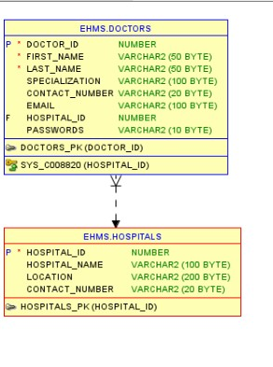

* **Billing and Patient:**

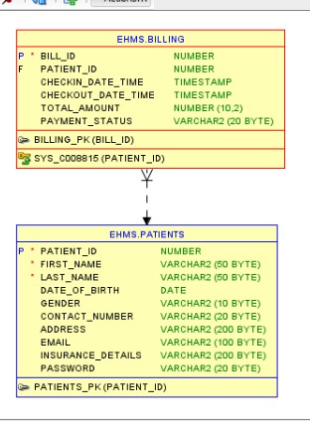

* **Appointment and Doctor:**

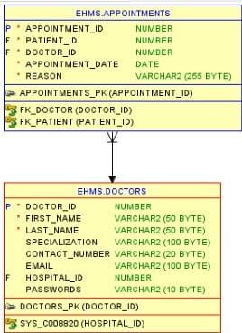

* **Doctor and Hospital:**



* **Billing and Patient:**

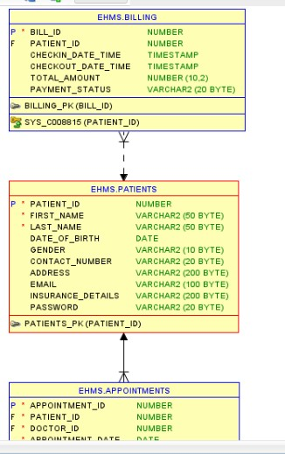

* **Appointment and Doctor & Appointment and Patient:**

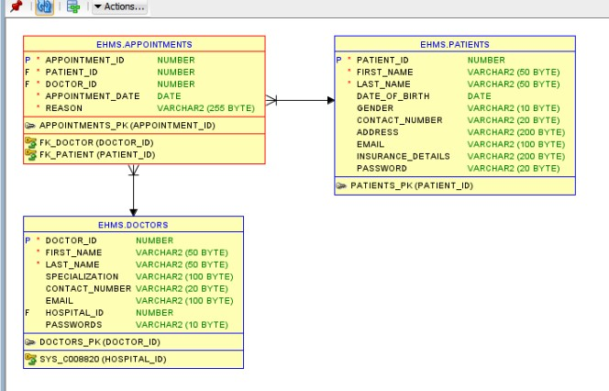

* **Appointment and Patient:**



**Tables:**

* **Billing Table:**

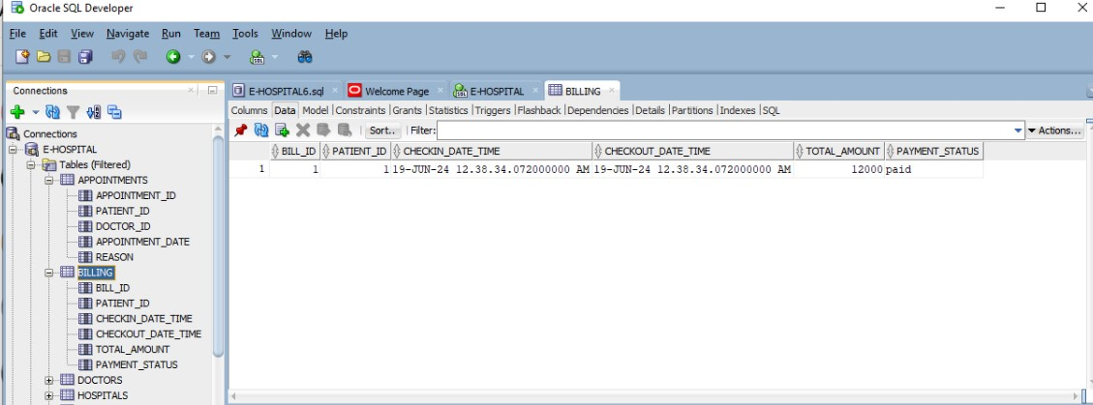

* **User Table:**

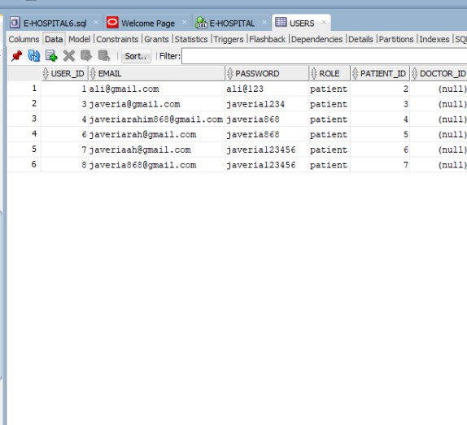

* **Doctor Table:**

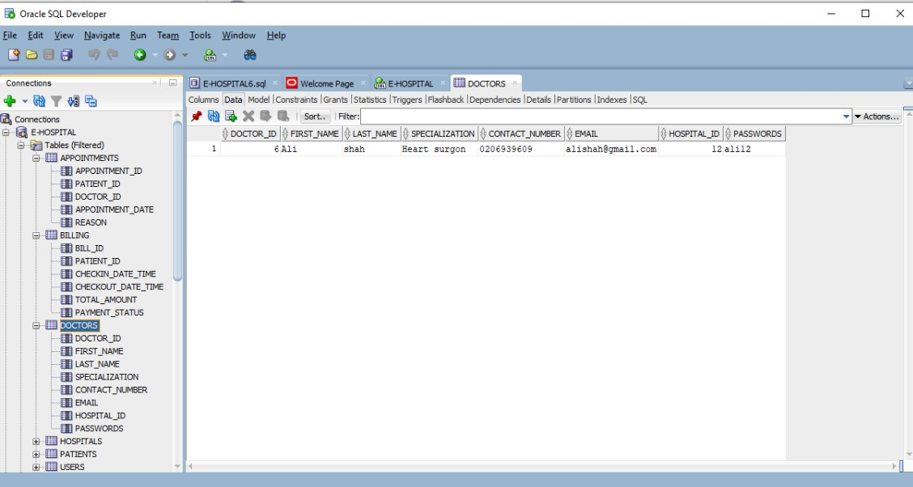

* **Hospital Table:**

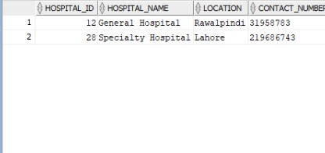

**Advantages:**

The advantages of implementing the e-Hospital Management System include:

**1. Efficiency Gains**: Automation reduces paperwork, minimizes errors, and speeds up processes, improving overall operational efficiency.

**2. Enhanced Patient Care:** Quick access to complete medical records, timely appointment scheduling, and medication management contribute to better patient outcomes.

**3. Cost Savings**: Reduced administrative costs, optimized resource allocation, and better inventory management lead to financial savings.

**4. Compliance and Security:** Implementing robust security measures ensures patient data confidentiality and compliance with healthcare regulations.

**Conclusion:**

In conclusion, the e-Hospital Management System using Oracle Database SQL represents a significant step towards modernizing healthcare administration. By integrating technology into hospital operations, it addresses current challenges, enhances patient care, and sets the stage for future innovations in healthcare delivery. Continued adaptation and improvement of the system will be essential to meet evolving healthcare needs and technological advancements effectively.

This comprehensive approach ensures that the e-Hospital Management System not only meets the immediate requirements of healthcare facilities but also supports long-term scalability, flexibility, and sustainability in healthcare management.